Nepal College of Information Technology
Balkumari, Lalitpur
Assessment
Fall 2009
Program: BE Time: 3 hrs
Semester: Fall FM: 100
Subject: Engineering Math-I PM: 50
Attempt ALL the questions.
The figures in the margin indicate full marks.

1. a) Examine the continuity and differentiability of the function
f(x) = 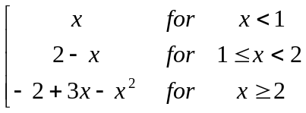
at x=1 and x=2.
OR
Prove that differentiability is the necessary condition for the continuity of the function but the converse may not always be true.
b) State and prove Lagrange's Mean value theorem. Give its geometrical interpretation. 7
2. a) Verify Rolle's theorem for f(x) = log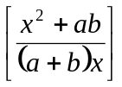 in [a, b]. 7
b) State L' Hopital's Rule and evaluate 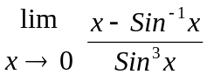 2+6
3. a) Find the center, vertices, foci, and length of latus rectum of the ellipse 9x²+16y²+18x-96y+9=0 7
b) Derive standard equation of hyperbola in the form of 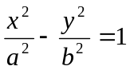 8
4. Integrate (any three): 3*5
i) 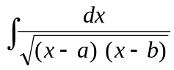
ii) 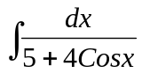
iii) 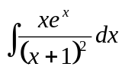
iv) 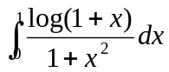
v) 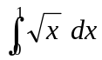 by summation method.
5. a) Find the area bounded by the curve y = x²+1, y = - x +3 and y-axis in the first quadrant. 7
OR
Find the volume of the solid generated by revolving the region enclosed by the triangle with vertices (1, 0) (2, 1), (1, 1) about x-axis.
b) Evaluate: 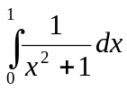 by 8
i) Trapezoidal Rule
ii) Simpson's Rule
and Compare the result with exact value taking n=4
6. a) Find the equation of plane through the points (2,4,5), (1,5,7) and (-1,6,8) by vector method. 7
b) What is the geometrical meaning of scalar triple product? Explain with necessary diagram, and show that 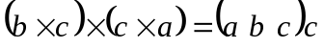 8
7. Answer the following. 2*5
i) Find the domain and range of the function f(x) =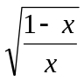
ii) If f(x) = x and g(x) =x²-2x, is Cauchy's mean value theorem applicable in [0, 2]?
iii) Find the equation of parabola having focus (-3, 0) and directrix x+5=0
iv) Integrate 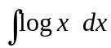
v) Find the area of parallelogram having the adjacent sides as 